PAPER: BETWEEN ALTERNATIVES AND RECYCLING

In our last two posts, we discussed plastic waste and food waste respectively. We would now like to end this “trilogy” talking about one more category of materials: paper.

Paper is fundamental for mankind: it is used to to store knowledge, information and contents, e.g. with books and notebooks, but it also has several other applications, e.g. cleaning and packaging.

Given the uses above mentioned, part of our daily life, it is not a big surprise that paper is produced in huge quantities; to give you an idea, [407 millions metric tons](https://www.statista.com/topics/1701/paper-industry/) of paper were produced worldwide in 2014, and roughly the same amount was consumed. These are huge number, especially considering that paper is produced from tree fibres, obtained cutting trees and, consequently, causing deforestation. Should we blame paper as the cause of deforestation? Is the huge amount of consumed paper the cause for the hectares of forests that every year are destroyed? According to [Phil Covington](http://www.triplepundit.com/special/sustainable-forestry-ip/deforestation-role-paper-products/), which studied the deforestation and the role of paper production in it involving Nigel Sizer, member of the [World Resources Institute](http://www.wri.org/) and president of the [Rainforest Alliance](http://www.rainforest-alliance.org/press-releases/new-president-nigel-sizer) since 2016, the answer in “no”. In fact, global deforestation is mostly caused by expansion of agricultural areas (approximately 80% of tropical deforestation), while paper and pulp industry have a lower impact in the overall figure and are more localized phenomena, e.g. in parts of Indonesia. However, says Covington, “the impact of paper industry cannot be ignored, especially when today, the southern United States forests are home to the world’s single largest pulp and paper production region in the world”.

The production and consumption of paper nowadays is unsustainable, but what could be done about such an essential material for modern societies? Functionalities accomplished by paper cannot be easily replaced. However, paper saving is fundamental, since each ton of recycled paper correspond to [17 saved trees](http://conservatree.org/learn/EnviroIssues/TreeStats.shtml). The criticality of paper recycling is even more evident if we think that paper waste is not just a source of pollution because of its disposal in landfills, which is approximately equal to 25% of the total landfill, but also because production of new paper causes deforestation, destroying one of the main sources of oxygen on the planet, entire ecosystems and one of the main consumers of the greenhouse gas carbon dioxide.

In this post, we will briefly discuss how paper waste can be reduced via institutional initiatives and thanks to newborn companies that exploit new technologies to be competitive. We will instead not cover the general topic of digitalization and its impact on paper consumption. This choice is due to the vastness of the topic and its complexity and controversial results, given that, how Richard Smith states in his 2011 study on the [paper environmental stustainability](http://repository.upenn.edu/cgi/viewcontent.cgi?article=1003&context=gsjod), “[in the last two decades] print volume has actually increased, as people now print emails, web pages, etc.”.

From the institutional point of view, we recall an initiative already mentioned in the previous post about food waste: the European Union is trying to fight waste with a [Legislative Proposal](http://ec.europa.eu/environment/circular-economy/index_en.htm) leading to a more circular economy. This project also involves paper, aiming to increase packaging waste recycling/re-using percentages (more precisely, 90% for paper) and to phase out landfill for recyclable waste, including paper, in 2025. This is not the only initiative around the world, for example we recall the Australian Capital Territory (ACT) [Waste Management Strategy](http://www.environment.act.gov.au/__data/assets/pdf_file/0007/576916/ACT-Waste-Strategy-Policy_access.pdf), an initiative started in 2011 and lasting until 2025 taking place in the federal district where Canberra, capital of Australia, is located. This initiative, similarly to the legislative proposal in EU, aims to reduce the amount of waste and go towards a progressive sustainability via a set of strategies against waste, which obviously also include paper.

From the company and entrepreneurship side, although paper recycling techniques are worldwide spread since several decades, new companies are raising, making a business out of waste management. The strength of these new companies is their capability to handle efficiently large quantities of waste preventing it from ending in landfills. This is the case of [EnCashea](https://encashea.com/), a company that allows waste producers can sell their recyclable scrap via an online platform. The scarp that can be sold ranges from newspaper to cardboard to books and magazines, but also includes other materials such as electronics and plastic. Such scrap is collected directly at the seller door via a previously scheduled pick-up time, after which the seller is paid.

As we just discussed, efforts are done both from the private and public side to fight paper waste. However, even if all the paper would be recycled, would this mean that no more new paper would be produced? Would all these efforts eventually lead to the end of the tree cut for paper production? Unfortunately, the answer is no. To understand the reason for this answer we must take a brief pause to shortly discuss the concept of recycling. The word “recycling” intrinsically implies a partial loss of quality of the product: something that is recycled does not have the same quality it used to have. For example, recycled glass produced by collecting different bottles has a slightly lower quality: when multiple glasses with different colours are recycled together, the resulting product has a brownish colour. This is the reason why, in some locations, glass collection has separated storage points for transparent, green and brown glass. In this case, such as in most of the metal cases, it would be more appropriate to talk about “re-evaluation” and “re-use” of the resource. This topic deserves a post on its own, so we will discuss it in the future. Meanwhile, let’s return back to paper, where we were considering that paper recycling cannot be a never-ending process. Indeed, says the website [earth911.com](http://earth911.com/business-policy/business/paper-recycling-details-basics/) taking the information from the [United States Enviromental Protection Agency](https://www.epa.gov/), along the recycling processes the fibres paper is made of become progressively shorter compared with virgin paper. Eventually, this leads to excessively short fibres for paper production. Fibres excessive degradation typically occurs after paper is recycled 5-7 times. This progressive degradation and the different quality grades of paper can be noticed in everyday life: newspapers have the lowest grade paper, while the printing paper is the paper with the highest grade. Given the limited amount of times paper can be recycled, the idea of a world where no new paper is produced by cutting trees seems impossible, and this is the reason why we will now discuss a couple of ideas aiming to replace normal paper in some of its functions.

At the beginning of this post, we discussed how paper is used in a broad set of areas. Among them, we mentioned how paper is used to read and take notes. Since we are very young, we spend time drawing, colouring and, later, writing, taking notes, sketching ideas. All of this occurs on paper sheets, one of the most familiar objects in everybody’s life and vehicle of our creativity. Probably this is the reason why, despite the world is getting more and more digital, technologies aiming to replace paper, books and notebooks are still not a broadly used as somebody may expect. Everybody has its own reasons to prefer sheets of paper to digital alternatives: somebody does not like looking at a bright screens, somebody else does not feel comfortable to take notes on a touch screen glass, and so on. Whatever is the reason, we think it could be included in the general statement that any alternative so far proposed does not feel as good as the original sheet of paper. Digital alternatives give constrictions, they lack or not perfectly emulate properties such as the indent pressure variation or the multiple colours, and despite a tablet is way lighter that a dozen of heavy books, often they are still quite heavy. Last but not least, the lack of chance to take two different papers or books and just place them one close to the other one to make a comparison or quickly jump from one to the other one, is something that annoys a lot of people. All of these constraints introduced on something so simple and fundamental in everybody life are the causes a lot of people do not accept alternatives to normal paper.

It is for this reason that [Techcrunch](https://techcrunch.com/2016/11/30/remarkable/), in one of its articles, discusses a brand new company trying to launch a new, paper-like tablet. The name of the product is [reMarkable](https://getremarkable.com/), a new tablet that, they claim, gets closer to paper than any other concurrent out there. Will it be actually a turning point in a sector that has been claimed as dead multiple times? Only time will tell, because the product is still not available: shipments will not begin before summer 2017, 4 years after the start-up was founded by Magnus Wenberg. They spent the last years developing the technology and the product, and we can just sympathize for this start-up and its hard-working crew. In case you wish to know more about this new incoming product, we suggest you to take a look at this [YouTube video](https://www.youtube.com/watch?v=34I27KPZM6g&t=11s), where you can have an overview of the features of this device.

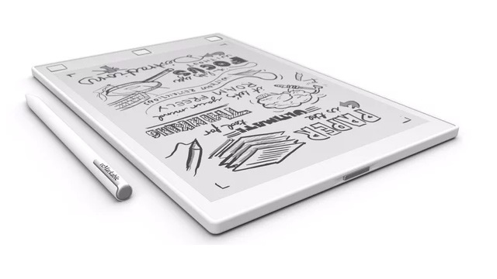  
Illustration 1: Credits: [Fastweb](http://www.fastweb.it/var/storage_feeds/CMS/articoli/527/527fb61d83d0cbc280e45dc1f704b4f3/640x360.jpg)

A second alternative to traditional paper we want to present you comes from the far East, where Japan’s biggest printing company, [Toppan Printing Co.](http://www.toppan.co.jp/english/), allied with the 2011 founded company [TBM](http://www.bloomberg.com/research/stocks/private/snapshot.asp?privcapid=326482706) to develop a substitute of paper called Limex. As the entrepreneur Nobuyosh Yamasaki, CEO of the newborn company, says [here](http://www.japan.go.jp/tomodachi/2016/summer2016/cuttingedge_technologies.html), they already completed a pilot plant, with also R&D functionalities, in February 2015. Such a plant, with a capacity of 6000 tons, will be flanked, at the end of this year by a second plant with a production capacity of 30 000 tons.

The concept behind Limex is very simple: as you can see in this [YouTube video](https://www.youtube.com/watch?v=ONCxX6yMDeI), Limex is a paper substitute made out of stone, more precisely limestone. It has all the typical properties of paper, but it does not consume water or wood. According to TBM’s statements to the [Sydney Morning Herald](http://www.smh.com.au/small-business/startup/start-up-turns-stone-into-paper-attracting-top-printing-company-investment-20161128-gsznid.html), “the water equivalent to the annual needs of 220 million people could be saved if just 5 percent of the world’s paper were manufactured using the new material”. Besides, TMB continues, “greenhouse gas emissions are about 20 percent less than traditional paper printing”.

According to all the above statements, there is a lot of potential behind this newborn technology, and we are really curious to see how this product will develop and if it will manage to become and effective concurrent of traditional paper.

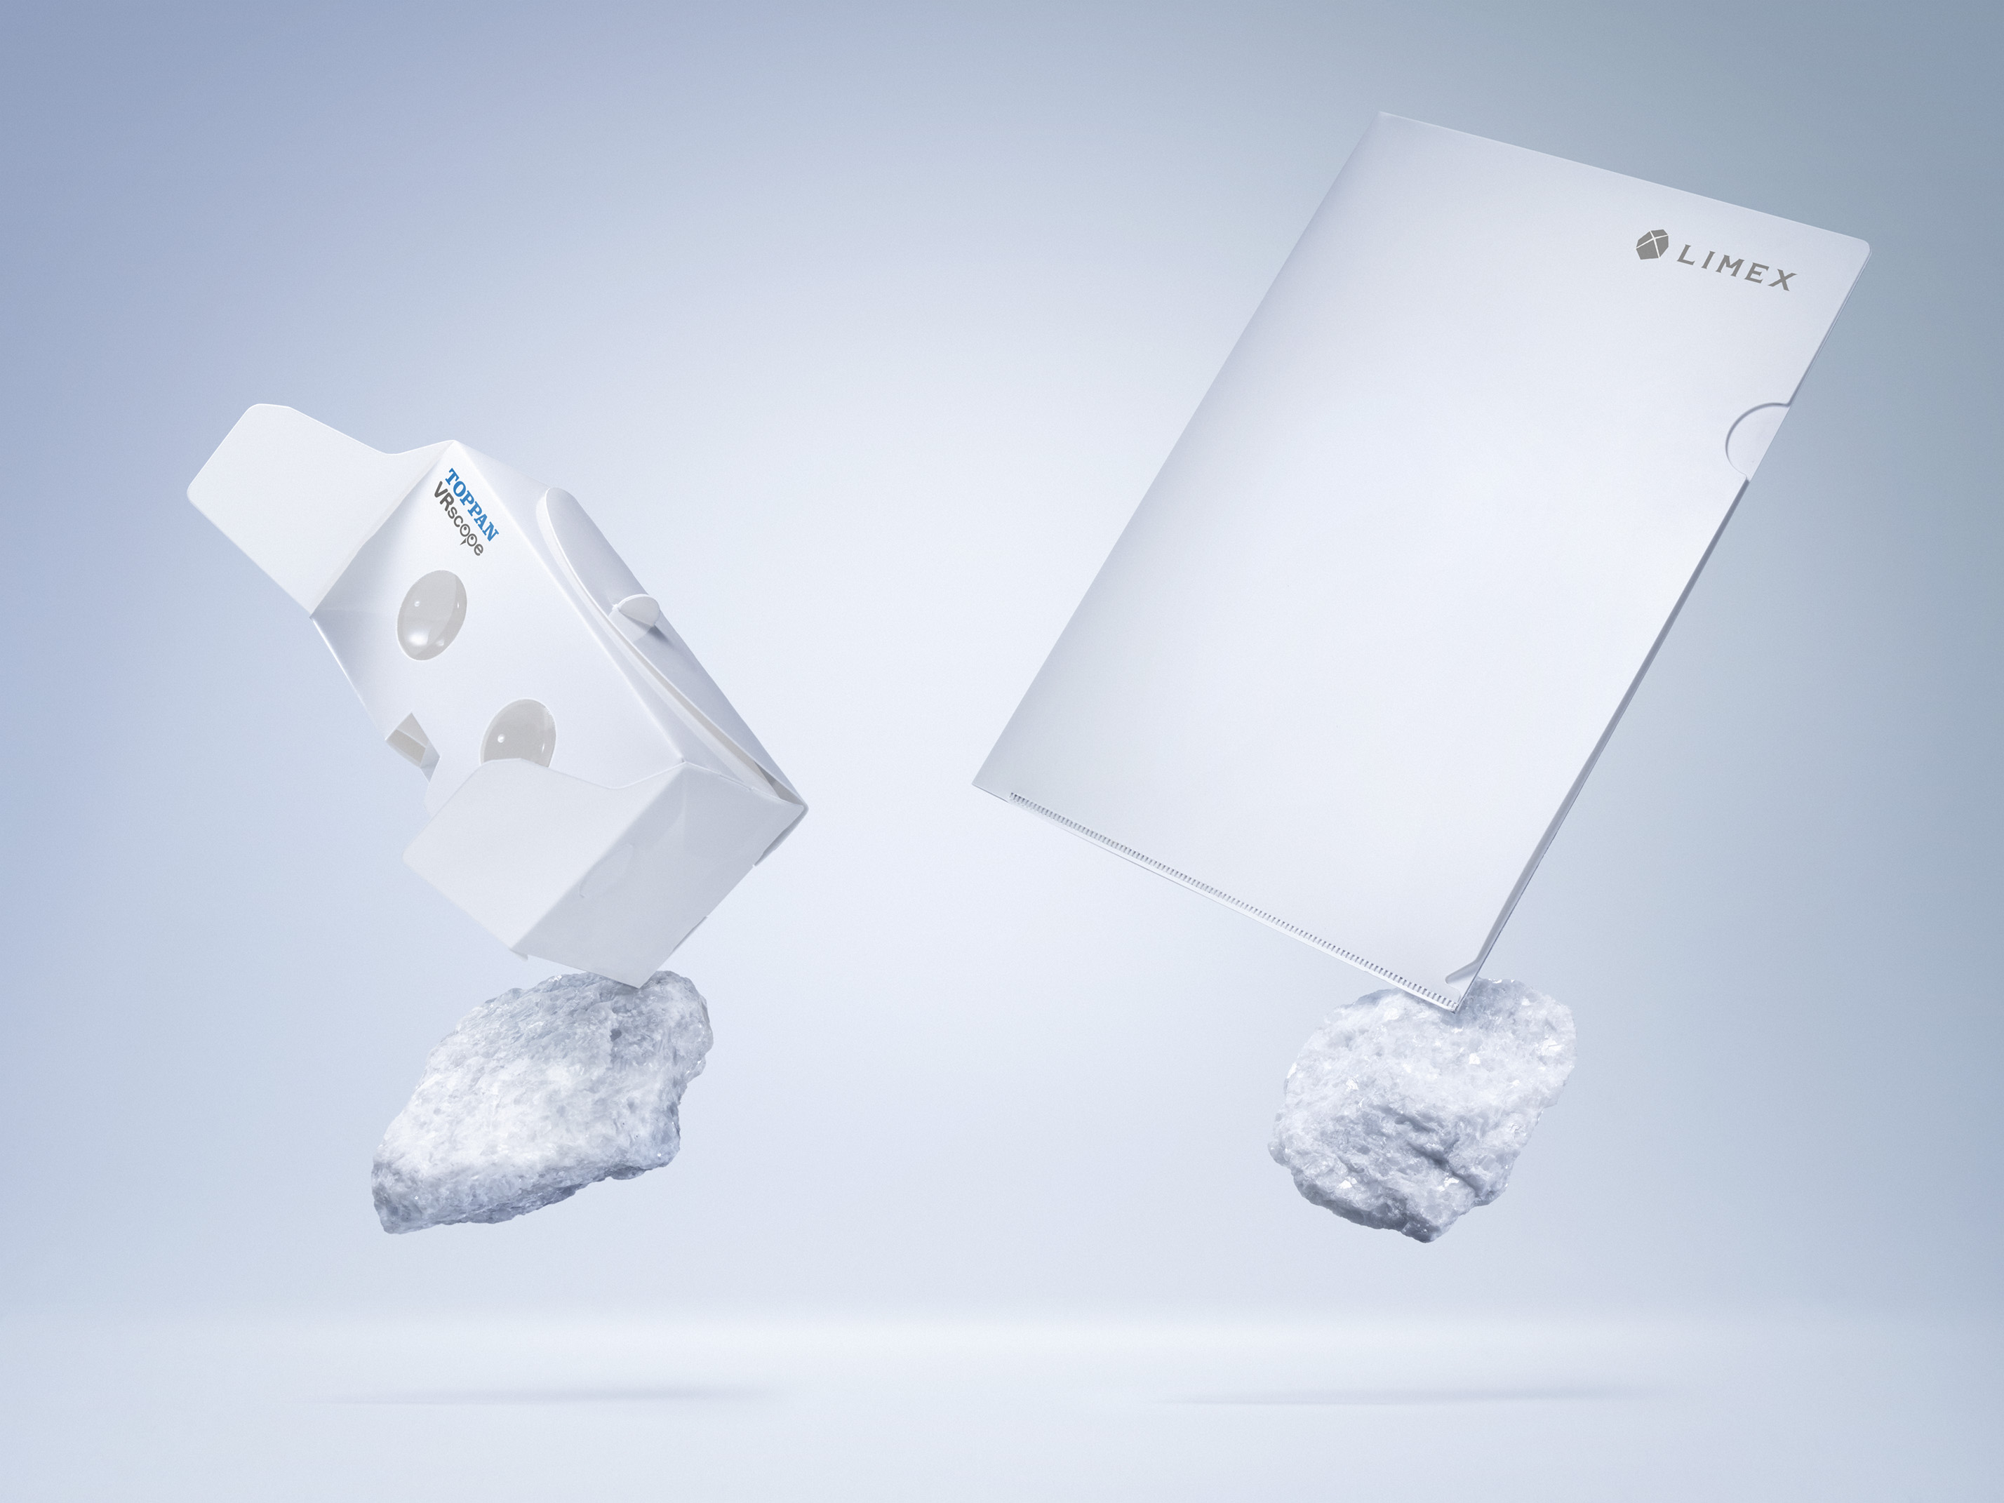  
Illustration 2: Credits: [Bloomberg](https://www.bloomberg.com/news/articles/2016-11-28/paper-made-from-stone-tempts-japan-s-biggest-printer-to-invest)

So far we have discussed how the future of paper consumption and waste may be, taking into account the public and private initiatives and possible incoming technologies that may reduce its consume in modern societies. Approaching the end of this post, we would like to conclude with a few words about the contribution everybody can give fighting paper waste, similarly to what done for the plastic and paper posts. Spread in the internet there is a remarkable set of websites with hints and guides for households to fight paper waste. We recall, among them, [Earthshare](http://www.earthshare.org/2008/09/shortening-the.html), which also proposes solutions for the companies, and [Bir](http://www.bir.org/industry/paper/ten-questions-on-paper-recovery-and-recycling/), which has a small Q&A webpage where people can have a better overview about the paper recovery via 10 simple but useful questions. Finally, in case you are in the mood for some *do it yourself*, we encourage you to take a look at [this guide](http://earth911.com/living-well-being/events-entertainement/recycle-your-own-paper/) to paper recycling which, in 4 steps, explain you how to recycle your own paper.

In conclusion, paper is a fundamental material for the society, being the main store of knowledge and vehicle of creativity, but it also attempts many others functions. However, paper production impacts very important resources on the Earth, therefore its waste must be fought and, in a world where more and more knowledge is produced and shared, alternatives must be considered for the future. We hope this post, despite its limited size and contents, helped you to better understand the importance of the paper waste issue and gave you some ideas about what may come tomorrow in this fundamental sector.